Client Business Requirements
Program / Project Name MISYS-47: TA Common Identifier

Program / Project No.: 0471
Document Version: 0.03 (2016-08-02)0.01 (2016-04-13)
Template Version: 1.00 (2013-02-28)
Prepared by: Clare Scully
Group: Client Change
Function: Client Service & Solutions
RBC Investor & Treasury Services™ is a global brand name and is part of Royal Bank of Canada. RBC Investor & Treasury Services is a specialist provider of asset servicing, custody, payments and treasury services for financial and other institutional investors worldwide. RBC Investor Services™ operates through two primary operating companies, RBC Investor Services Trust and RBC Investor Services Bank S.A., and their branches and affiliates.
In the UK, RBC Investor Services Trust operates through a branch authorized by the Prudential Regulation Authority and regulated by the Financial Conduct Authority and the Prudential Regulation Authority. The Dubai Branch of RBC Investor Services Trust is regulated by the Dubai Financial Services Authority.
In Australia, RBC Investor Services Trust is authorized to carry on financial services business by the Australian Securities and Investments Commission under the AFSL (Australian Financial Services Licence) number 295018.
In Singapore, RBC Investor Services Trust Singapore Limited (RISTS) is licensed by the Monetary Authority of Singapore (MAS) as a Licensed Trust Company under the Trust Companies Act and was approved by the MAS to act as a trustee of collective investment schemes authorized under S 286 of the Securities and Futures Act (SFA). RISTS is also a Capital Markets Services Licence Holder issued by the MAS under the SFA in connection with its activities of acting as a custodian.
In Hong Kong, RBC Investor Services Bank S.A. is a restricted license bank and is authorized to carry on certain banking business in Hong Kong by the Hong Kong Monetary Authority. RBC Investor Services Trust Hong Kong Limited is regulated by the Mandatory Provident Fund Schemes Authority as an approved trustee.
® / ™ Trademarks of Royal Bank of Canada. Used under licence.

Revision List
Ver. # | Date | Author | Description | Distribution
0.01 | 13/04/2016 | Clare Scully | Initial draft to kick off documentation process | Internal
0.03 | 02/08/2016 | Clare Scully | Updated to give feedback to comments raised by Lizy DiVetta 29/07/2016 | All Stakeholders

Table of Contents
The purpose of this document is to:
- Provide a vision for the expected outcome of the project.
- Act as a form of agreement, outlining project particulars and deliverables.
- Note: Requirements do not necessarily have to be collected and presented in this artefact format. If requirements software tools or alternate formats such as use cases are being used, then printed output of these formats can be substituted here.
Revision List 2
Table of Contents 1
1. Executive Summary 1
1.1. Project Identification 1
1.2. Related Documents 1
2. Project Description 1
2.1. Purpose 1
2.2. Critical Success Factors 1
2.3. Processes Impacted 1
2.4. Business Requirements Scope 1
3. Assumptions, Dependencies & Constraints 1
3.1. Assumptions 1
3.2. Dependencies 1
3.3. Constraints 1
3.4. Process Flows 1
3.5. Requirements 1
3.5.1. Functional Requirements 1
3.5.2. Non – Functional Requirements 1
4. Sign off Block 1
Reviewers 1
5. Appendix 1 – New Fund Identifier Code 1
6. Appendix 2 – “As Is” and “To Be” Sample Files 1

- Executive Summary
  - Project Identification
Project Name | Mediolanum Enhancements 2016 | Project No. | 0471
Program Name | As above | Program No. | As above
Project Start Date | 2016 | Project End Date | 2016
Project Manager | N/A | Group & Function | N/A
Program Manager | Kate Cullen | Group & Function | Associate Director, Client Change
Sponsor | Renato Moreschi | Group & Function | MD, Client Operations
  - Related Documents
Document Name / Description | Author | Purpose / Comments
New Fund Common Identifier Code | Clare Scully | Code that must be stored in SARA
“As Is” and “To Be” Sample Files | RBC | Sample files for illustrative purposes

- Project Description
  - Purpose
- Mediolanum Dublin will start to use new systems late 2016 which will result in a change to the way in which they communicate with RBC.
- These systems are FusionInvest (Portfolio & Risk Management system) and Intellimatch (Reconciliation system).
- Mediolanum have requested various information from RBC that will feed both systems:

Flow: RBC -> Mediolanum (High Level)
FusionInvest | Intellimatch
Custody & Fund Accounting trade file for Delegate Manager trades | Custody & Fund Accounting trade files for MAML trades
GFP confirmation of trading | Custody & Fund Accounting trade file for Delegate Manager trades
FX forwards initiated by RBC (e.g. COS) | Custody positions for all asset types (MAML and Delegate Managers)
Corporate Actions for MAML and Delegate Managers | Valuation for all security positions held on the portfolio (MAML and Delegate Managers)
Custody invoice file for MAML and Delegate Managers | Settled Cash and cash movement report (MAML and Delegate Managers)
Estimated / Confirmed Cash Flows | GFP confirmation of MAML trading
 | Income (dividends) for MAML funds
 | Corporate Actions for MAML and Delegate Managers
 | Custody invoice file for MAML and Delegate Managers

- The purpose of this document is to provide the requirements for one sub-category of the category: Estimated / Confirmed Cash Flows.
  - Critical Success Factors
- Successful loading of cash in/out flows to Fusion Invest to facilitate Fund Manager trading
  - Processes Impacted
Process | Impact  (New/Deleted/Modified)
Amendment to existing report | Modified
Storing of Custody Fund Identifier in the TA System | New
  - Business Requirements Scope
Business Requirements Scope
Communicating estimated and confirmed in/out flows at class level to Fusion Invest, Mediolanum’s new Front Office system
Scope Inclusions
- All funds (Dublin and Luxembourg) – impacting 2 regions of the TA system SARA, FETA and DBLN – excluding Gamax FCP as RBC I&TS is not the TA for these funds
- Storing of new common identifier, a concatenation of the Multifonds Sub-fund code and the Focus/Multifonds Manager Code, at class level. The identifier will be an equivalent of the PTG that is credited/debits from/to the collection account when there are subscriptions and redemptions
- Addition of this new common identifier to existing reports “POMS” estimated and confirmed flows files.
- New diffusion details for the reports
Scope Exclusions
- Any change to the report other than those referenced in this document

- Assumptions, Dependencies & Constraints
  - Assumptions
Description of Assumption & Context | Impact if Not True | Recommended Action /  Resolution / Comments
It is assumed RBC can retain the current filename convention. Please refer to OPR4 in Section 3.5.1 for more information on the file names which is more of less in line with the convention suggested by Cronos for the files. | Requirements set out in this document may not be fully correct | Mediolanum/Cronos to formally confirm requirement
In the “as is” model Mediolanum load the POMS estimated / confirmed files to their data warehouse as well as loading the file to AIMS.  It is assumed that Mediolanum still require delivery of the files for the purpose of loading to the data warehouse. They may require some small development to cater for the additional field being added to the report. | Requirements set out in this document may not be fully correct | Mediolanum to confirm the FTP site used for the data warehouse (the RBC FA/CU gateway and user ID DBMEDIO) should still receive the POMS files, and that adding the additional field to the report will not cause an issue on their side
  - Dependencies
Description of Dependency | Impact if Not in Place | Recommended Actions /  Resolution / Comments
Resource – Mediolanum/Cronos to review docs and be available for UAT and queries | Delivery timeframe requested by Mediolanum may not be met | Schedule to be shared with all parties once available
Set up of functionality for RBC to push file to Mediolanum’s SFTP site, This is being progressed as a separate item with Mediolanum and is not in place at the time of writing of this document. | N/A | Details of SFTP to be shared closer to delivery date
  - Constraints
Description of Constraint | Impact if Not in Place | Recommended Actions /  Resolution / Comments
Technical constraints may be identified as part of the IT detailed analysis | All requirements may not be able to be delivered | Results of detailed analysis to be shared with all stakeholders once available

  - Process Flows
High level ‘to be’ flows are outlined below. Mediolanum system information has been included for illustrative purposes.
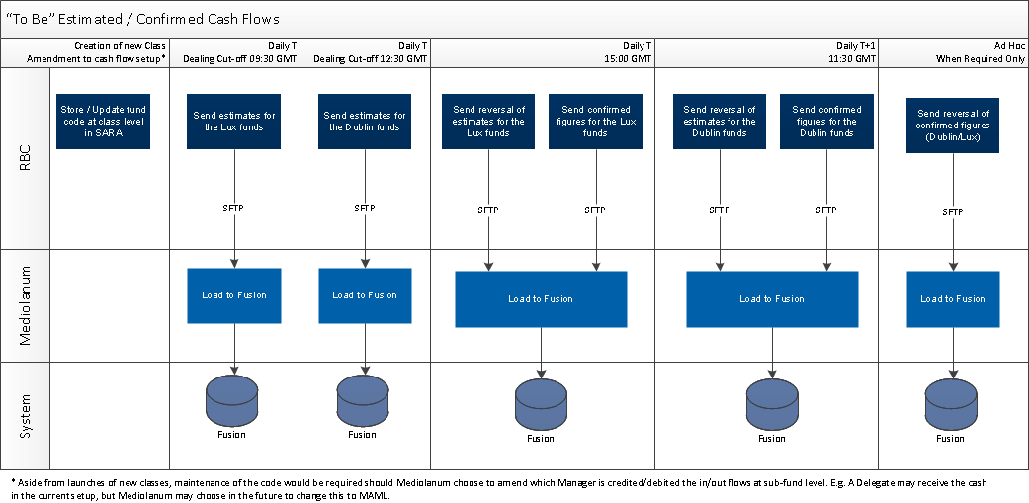

For illustrative purposes, the below is a picture outlining the link between a share class, and the new Custody/FA code to be stored:

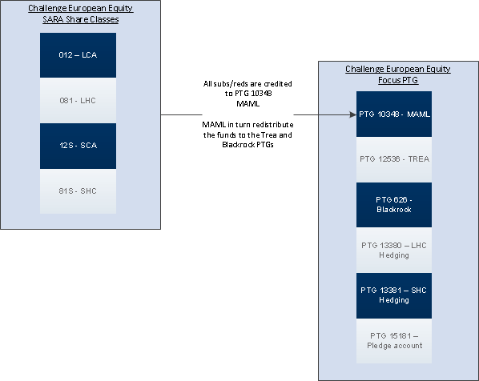
  - Requirements
    - Functional Requirements
General Requirements
Client Requirements
Product, Features & Options
Marketing & Sales
Communications
Credit & Risk
Other

ID | Requirement | Priority  1=high  5=low | Stability  High  Med  Low | Origin | Benefit
CR1 | Estimated and confirmed figures sent daily including required fund identifier | 1 | High | Mediolanum | To load cash information to Fusion Invest

Operational Requirements
Operational Requirements
ID | Requirement | Priority  1=high  5=low | Stability  High  Med  Low | Origin | Benefit
OPR1 | Mediolanum require that RBC include a fund common identifier in the existing POMS estimated and confirmed reports.  The field is a concatenation of the sub-fund Fund Accounting / Multifonds identifier, and the Custody / Focus manager ID.  The code equates to a particular PTG at Custody level. Multiple PTGs are opened per sub-fund at manager level. From a TA perspective, the code will indicate which PTG in each sub-fund is debited or credited cash at subscription/redemption.  It must be possible to store the new common identifier in the TA system SARA at class level.  The code must be stored at share class level - even if all classes on the same sub-fund will share a common identifier. This is because the report which must include the code is at class level.  A list of the required identifier per share class is provided in Appendix 1. | 1 | High | Client Change | To meet client requirement
OPR2 | There must be a once off load of the data into this new field, for existing share classes.  Please refer to Appendix 1 for the data to be loaded. | 1 | High | Client Change | To meet client requirement
OPR3 | The field must be maintained – for any new share class the code must be added to SARA.  Should Mediolanum ever change the PTG/manager at Custody level that receives the fund subscriptions or is debited at redemption, an update must be made to the identifier stored in SARA. | 1 | High | Client Change | To meet client requirement
OPR4 | The existing POMS reports must be updated to include this new field in the rightmost field – position 17.  The field must be called “External Fund Reference”.  The POMS reports are named:  Estimates: Poms_shs_e_YYYYMMDD  Reversal of Estimates:  Poms_shs_er_YYYYMMDD  Confirmed Figures:  Poms_shs_c_YYYYMMDD  Reversal of Confirmed Figures (only used for contingency purposes):  Poms_shs_cr_YYYYMMDD  They are available from the below menu path in the SARA regions DBLN and FETA:  Reports > Specific Reports > Cash Report > POMS Automated Cash File  The 4 reports are generated from the one menu path.  All 4 reports share the same format and field contents but are run based on different parameters.  Please refer to Appendix 2 for an example of the “to be” report with the additional field. | 1 | High | Client Change | To meet client requirement
OPR5 | Rather than amending the existing reports, a new menu path should be created with the new version of the file.  This is because the updates require a monthly SARA release.  Mediolanum intend to go live with Fusion Invest in October 2016. This does not exactly correspond with a SARA release date. As a result the reports will be released into Production by RBC in advance of October 2016. As Mediolanum will not be in a position to accept the new format and during the cross over period TA must use the old menu.  There may also be a requirement for a parallel run of the files for a short period. | 1 | High | Client Change | To meet client requirement
OPR7 | The existing POMS reports are sent to 2 FTP sites.  - The RBC TA gateway. Mediolanum pull the files and load them to Mediolanum’s current front office system AIMS.  - The RBC FA/CU gateway. Mediolanum pull the files and load them to Mediolanum’s data warehouse.  In the “to be” model, a new SFTP will be created for exchange of files with Fusion Invest. RBC will push files to the FTP site, rather than Mediolanum pulling the data.  The diffusion details for the new menu/reports must be:  - The new SFTP which is being managed as a separate requirement by T&O (RBC’s IT) and will be confirmed closer to the go-live date  - The RBC FA/CU gateway – user ID DBMEDIO. | 1 | High | Client Change | To meet client requirement

Third Party Requirements
Third Party Requirements
Measurement Requirements
Measurement Requirements
    - Non – Functional Requirements
Non- Functional Requirements
Audit
Business Continuity
Data Retention
Documentation / Training
Fraud
Privacy
Volume Impact
Security
Availability
Hardware
Software
Reliability
Scalability
Performance
Interface
Infrastructure

- Sign off Block
Role | Name | Group & Function | Signature | Date
Project Manager | Noel Nolan | Mediolanum
Program Manager | Kate Cullen | RBC

Reviewers
Reviewers are acknowledging that they have reviewed the Business Requirements and are in agreement with the content.
Role | Name | Group & Function | Signature | Date
Mediolanum | Lizy di Vetta | Mediolanum
Mediolanum | John Burrows | Mediolanum
Cronos | Steve Lazouras | Cronos
Cronos | James Shillingford | Cronos
SME | Paul Denny | Shareholder Services
BSA | Karim Mouhoud | IT
BSA | Delphine Tempesta | IT
IT PM | Sebastien Paulissen | IT

- Appendix 1 – New Fund Identifier Code
DBLN:


FETA:
TBC

- Appendix 2 – “As Is” and “To Be” Sample Files
“As Is”
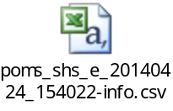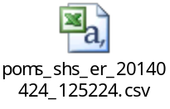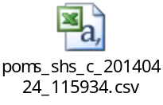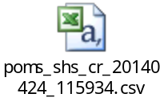

“To Be”
Only one example is included but for all 4 reports the new field will be added to position 17.

